Title Page
Evaluating Neonatal Resuscitation Efforts in Bombali District, Sierra Leone Through Analysis of Data from the CHAMPS Program

by

Sangki Oak

BSEE, Duke University in the City of Durham, 1997

Submitted to the Graduate Faculty of the

Multidisciplinary MPH Program

Graduate School of Public Health in partial fulfillment

of the requirements for the degree of

Master of Public Health

University of Pittsburgh

2020

Committee Page
UNIVERSITY OF PITTSBURGH
Graduate School of Public Health

This essay is submitted

by

Sangki Oak

on

April 17, 2020

and approved by

Essay Advisor:
David Finegold, MD
Director, Multidisciplinary MPH Program
Professor
Human Genetics
Graduate School of Public Health
University of Pittsburgh

Essay Readers:
Joanne Russell, MPPM
Director, Center for Global Health
Assistant Professor
Behavioral and Community Health Sciences
Graduate School of Public Health
University of Pittsburgh

Wesley M Rohrer, PhD
Associate Professor Emeritus
Health Policy and Management
Graduate School of Public Health
University of Pittsburgh

Copyright © by Sangki Oak

2020

Abstract
David Finegold, MD

Evaluating Neonatal Resuscitation Efforts in Bombali District, Sierra Leone Through Analysis of Data from the CHAMPS Program

Sangki Oak, MPH

University of Pittsburgh, 2020

Abstract
After being ravaged by a devastating civil war, and the recent Ebola outbreak weakening an already crippled healthcare system, the country of Sierra Leone struggles with one of the worst health statuses in the world. The Ministry of Health and Sanitation (MoHS), local and international NGO’s, and a variety of health care professionals are striving to help improve the health of the population, but there is still much work to be done. One area that these local and international champions are working to improve is to reduce stillbirths and death of children under 5 years old. This paper explores the Child Health and Mortality Prevention Surveillance (CHAMPS) Program in Sierra Leone which seeks to collect data regarding the deaths of these children. It also describes a study conducted in the summer of 2019 which used data collected by CHAMPS to investigate newborn resuscitation efforts at the health facilities in the region and provided some observations and conversation with health care workers regarding newborn resuscitation that occurred during the course of the study.
The public health importance of this program is that by collecting and analyzing the CHAMPS data, a better understanding of the cause of death for these newborns and children can be obtained and, more importantly, initiatives can be implemented by the government and MoHS to attempt to reduce these deaths. Regarding the study on newborn resuscitation, the public health significance of this investigation is that it provides one of the first public health applications of the CHAMPS data to better characterize newborn resuscitation efforts by health care providers. While the results were inconclusive due to limited documentation, along with the observations and conversations, it does suggest that expanded training may be needed to increase newborn resuscitation efforts for apneic newborns. This could potentially lead to expansion of newborn resuscitation training to the hospitals and Peripheral Health Units which would help to decrease stillbirths and newborn deaths in the Bombali Shebora chiefdom of Sierra Leone.

Table of Contents
Abbreviations x
Acknowledgements xi
1.0 Introduction 1
1.1 Sierra Leone 1
1.2 Practicum 2
1.3 CHAMPS 2
1.3.1 Overview 2
1.3.2 Sierra Leone CHAMPS 4
1.3.3 Daily Operations 5
1.3.4 Community Engagement 6
1.3.5 Challenges 8
2.0 Newborn Resuscitation Study 10
2.1 Background 10
2.2 Methods 12
2.3 Data Analysis Results 12
3.0 Observations and Conversations 16
3.1 Newborn Resuscitation Observations 16
3.1.1 ETAT+ neonatal resuscitation training 17
3.1.2 Labor Ward 18
3.1.3 Operating Theatre 21
3.2 Conversations 22
3.2.1 PHUs and Private Hospitals 22
3.2.2 MRH Labor Ward 24
3.2.3 MRH Operating Theatre 26
4.0 Discussion 29
5.0 Areas for Improvement 31
6.0 Public Health Relevance 33
7.0 Limitations 34
8.0 Conclusion 35
Bibliography 36

List of Tables
Table 1. Were resuscitation efforts attempted? 13
Table 2. Number of stillbirths, documentation if resuscitation attempted or not, and stillbirth resuscitation efforts by location 14
Table 3. Numbers of stillbirth deliveries, resuscitation efforts of all stillbirths, and resuscitation efforts on fresh stillbirths by delivery attendant type 14
Table 4. Number of stillbirths, fresh stillbirths, and resuscitation efforts by mode of delivery 14
Table 5. Phase of delivery that stillbirth was confirmed and if resuscitation atatempted 15
Table 6. Number of stillbirths and resuscitation attempts by method of stillbirth confirmation 15

List of Figures
Figure 1. Baby Record and Summary of Labor (Photo by Sangki Oak) 20
Figure 2. SCBU referral template (Photo by Sangki Oak) 20
Figure 3. Helping babies breath receipt booklet (Photo by Sangki Oak) 23
Figure 4. Anaesthesia record in maternal patient record (Photo by Sangki Oak) 28

Abbreviations
APGAR – Appearance/Pulse/Grimace/Activity/Respiration (to assess newborns)
BVM – Bag valve mask
CDC – Center for Disease Control
CHAMPS – Child Health and Mortality Prevention Surveillance
CHO – Community Health Officer
ENAP – Every Newborn Action Plan
ETAT+ – Emergency Triage Assessment and Treatment Plus
HBB – Helping Babies Breathe
MITS – Minimally Invasive Tissue Sampling
MoHS – Ministry of Health and Sanitation
MRH – Makeni Regional Government Hospital
PHU – Peripheral Health Unit
REDCap – Research Electronic Data Capture
SCBU – Special Care Baby Unit
TBA – Traditional Birth Attendants
UNICEF – United Nations Children’s Fund
WHI – World Hope International
WHO – World Health Organization

Acknowledgements
To my professors and mentors at the Graduate School of Public Health for their wisdom.
To the people of Sierra Leone for their inspiration.
And to my wife and son for their support.

Study data were collected and managed using REDCap electronic data capture tools hosted at CHAMPS Sierra Leone.^{13,14} REDCap (Research Electronic Data Capture) is a secure, web-based software platform designed to support data capture for research studies, providing 1) an intuitive interface for validated data capture; 2) audit trails for tracking data manipulation and export procedures; 3) automated export procedures for seamless data downloads to common statistical packages; and 4) procedures for data integration and interoperability with external sources.

Introduction

Sierra Leone
Sierra Leone is a country located on the western coast of Africa with a land mass slightly smaller than the state of South Carolina. Historically, this nation had been a place for European trade for timber, ivory, and later slaves. After the American Revolutionary War, the country became a resettlement site for freed African-American slaves by the British. The history of Sierra Leone is tumultuous, and its people have suffered many challenges and hardships. More recently, between 1991 and 2002 Sierra Leone suffered a brutal civil war that killed 50,000 people, displaced millions, and destroyed many of its institutions. As the country began to rebuild itself, in 2014 the Ebola outbreak in Western Africa killed thousands and sowed distrust in the population of the healthcare system.¹
As such, Sierra Leone finds itself with one of the worst health statuses in the world. Life expectancy of Sierra Leoneans is 59.8 years, which is 218th in the world. Maternal mortality is one of the highest in the world at 1,120 deaths per 100,000 live births and infant mortality is among the top ten at 63.6 deaths per 1000 live births. And with a physician density of only 0.03 physicians per 1000 people, which means an estimated 200 doctors in the entire country of 6.6 million people, access to quality healthcare is a challenge.¹

Practicum
In May of 2019, I traveled to Sierra Leone with my wife and one-year old son to spend six weeks working with World Hope International (WHI) and the Sierra Leone Child Health and Mortality Prevention Surveillance (CHAMPS) network. I had been seeking an overseas practicum experience for my master’s in public health and my wife had a previous connection with World Hope International. We were placed in contact with Carrie Jo Cain, the Health Programs Specialist at WHI in Sierra Leone. WHI is partnered with several other organizations to conduct the CHAMPS program in Sierra Leone and is tasked with child mortality surveillance activities. WHI wanted to examine the data collected by CHAMPS so far to attempt to determine newborn resuscitation efforts in the hospitals and clinics and felt that it would be beneficial to perform this study. In addition, I would have the opportunity to observe resuscitation efforts in the hospital, the operations of the CHAMPS program, and the healthcare system in Sierra Leone.

CHAMPS

Overview
In the era of evidence-based medicine, improvements in medical practice and healthcare efforts require quality research. And quality research requires high-quality data. In the healthcare systems of many low- or middle-income countries, though, this may be difficult or even impossible. Patient records are usually maintained in paper form which would require great efforts to individually gather and read through the files to collect needed data. The information in these paper files are collated all together and offer limited ability to search for particular conditions or outcomes. In addition, paper records may often be lost or damaged resulting in missing data. In a retrospective study, using only clinical data from hospital records may fail to capture all the needed data and the opportunity for collecting other information is lost by the time of the study. Fortunately, electronic data regarding child and neonatal deaths is slowly becoming available in several of these low-income countries through the CHAMPS network.
The CHAMPS network was developed to produce high-quality data on stillbirths and deaths in children under the age of 5 years old in sub-Sahara Africa and South Asia. This project uses several different sources of information to determine the cause of death of the individual child or newborn in order to identify sources of childhood mortality in these regions. The vision is that by filling these knowledge gaps, initiatives can be developed to help prevent future childhood deaths and illness. This project has currently been implemented in Bangladesh, Ethiopia, Kenya, Mali, Mozambique, South Africa, and Sierra Leone and is funded through a grant from the Bill and Melinda Gates Foundation. As of February 9, 2020, the CHAMPS network has collected data for 4,067 under-5 deaths and stillbirths across these sites.²
The pilot program for the Sierra Leone site was established in 2017 and official data collection began on June 2, 2018. The Sierra Leone CHAMPS network currently covers the Bombali Shebora chiefdom of Bombali District, including Makeni City. The project followed a phased implementation framework comprised of four phases with increasingly exhaustive mortality reporting and data collection. The Sierra Leone site entered the fourth phase in February of 2019 with the start of specimen collection, which includes minimally invasive tissue sampling (MITS).

Sierra Leone CHAMPS
Upon the death of a child under 5 or delivery of a stillbirth within the catchment area of the Bombali Shebora chiefdom, facility reporters at healthcare facilities (hospitals or Peripheral Health Units (PHUs)), community reporters within the villages, or family members will call the 117 national call center to initiate an alert. A member of the CHAMPS team is on call 24/7 and will then visit the location of the deceased child to obtain consent from the family and determine eligibility for enrollment in the network. If consented and eligible, a verbal autopsy and social autopsy will be conducted from the family. The verbal autopsy is administered by trained interviewers using standardized age-group specific WHO verbal autopsy questionnaires. In addition, health facility patient records, if available, are reviewed to extract a clinical abstract regarding the circumstances leading to the patient’s death, including vaccinations, maternal health, and pregnancy history. If the family also consents for specimen collection, then MITS sampling will be performed within 24 hours. MITS sampling is conducted using biopsy needles to collect specimens from the child’s lungs, heart, brain, liver, bone marrow, spleen or kidney, and skin lesions if present. For stillbirths and neonatal deaths, samples from the placenta, membranes, and umbilical cord are also collected when possible. The specimens are frozen and stored at -80°C or in liquid nitrogen. A portion of the specimens are tested in an in-country lab while a duplicate of the specimen is sent to the CDC in Atlanta, GA for further testing and storage. All this information is then uploaded into the CHAMPS database which uses the REDCap (Research Electronic Data Capture) electronic data capture tool.

Daily Operations
The CHAMPS program in Sierra Leone operates as a collaboration between several partners: The Sierra Leone Ministry of Health and Sanitation (MoHS), CDC-Sierra Leone, Crown Agents, FOCUS 1000, ICAP, and World Hope International (WHI). The MoHS participates as an agent for community access and engagement and provides data to inform actionable activities. CDC-Sierra Leone provides technical assistance to CHAMPS. Crown Agents is a fiscal agent that manages the various implementation partners of the CHAMPS Sierra Leone site. FOCUS 1000, a Sierra Leone NGO that concentrates on the first 1000 days of a child’s life, directs the Social Behavioral Science component of CHAMPS Sierra Leone. ICAP supports the laboratory and diagnostics work, as well as the informatics and data systems. WHI conducts the child mortality surveillance activities. While each partner is responsible for their portion of the program, there is frequent coordination between the different entities. Several scheduled weekly team meetings allow program-level communication and problem solving between all the partners for CHAMPS Sierra Leone, while daily meetings including WHI and ICAPS staff allow updates on the progress of the day and any smaller issues encountered.
Most of my experience in Sierra Leone was working with WHI which allowed me to observe the daily operations of the mortality surveillance activities. Aside from Carrie Jo Cain, the entire WHI team are local Sierra Leoneans and consists of about two dozen people. The team has a clinical coordinator, two surveillance supervisors, 14 community interviewers, two project assistants, an IT assistant, a transport officer, and five drivers. Every morning began with a team meeting at the WHI office which reviews any cases which were reported overnight, the plan for the day, and any issues or concerns. Aside from responding to activations during the day through the 117-alert system, a pair of community interviewers also perform daily rounds of the regional hospital and several of the PHUs to survey for any child deaths or stillbirths that were not reported through 117. Other members of the team travel to villages to conduct verbal and social autopsies from families for consented cases while additional members review hospital records to collect clinical data regarding cases under investigation. Investigations of child deaths and stillbirths may take several days and a large chalkboard on the office wall keeps track of the various tasks for each reported case that are to be completed by team members. At the end of the day, another meeting is conducted at the CHAMPS offices to review the progress of cases that day, outline work for the next day, and address issues that occurred during the day. Two community interviewers and a driver are on-call overnight to respond to any alerts that occur during the night. These activities operate 365 days a year, 7 days a week, 24 hours a day.

Community Engagement
Despite these partners and their team members toiling relentlessly to collect data on child and newborn mortality, their efforts are fruitless without support and buy-in from the community and its various stakeholders. At a minimum, there must be enough knowledge of CHAMPS and the importance of the program so that activation of the 117 alert system occurs shortly after a child’s death and that the family provides consent for the collection of the data. There were several examples that were observed during the practicum experience which highlighted the community engagements that CHAMPS Sierra Leone provides to various stakeholders to increase understanding and acceptance of the program. In order to spread awareness, radio advertisements and news segments explaining the CHAMPS program are broadcast regularly to inform the public of the program, its importance for public health, and how to contact CHAMPS through the 117-alert system. A religious leader training program was conducted to help increase acceptance of the CHAMPS program, in particular the MITS sampling, within the community. This training program was divided into separate sessions for Christian and Islamic leaders with faith-specific material which provided religious support for mortality surveillance and MITS sampling. It also allowed the different religious leaders to voice their concerns and have their questions answered regarding the program so that they can then share with their congregations. Training was also provided for the community and facility reporters for CHAMPS. The community reporters are members of a village, usually an elder or other community leader, who volunteer to provide activation of the mortality surveillance alert when a child dies in their village. The facility reporters are healthcare workers, such as nurses, midwives, or administrative personnel, who can provide the same activation within the hospitals or PHUs. The training sessions employed team-based learning to review topics regarding mortality surveillance and the CHAMPS program, where the participants were divided into groups that would discuss the various topics, write them down, and have a group leader present their conclusions to the rest of the participants. This training also provided a forum for feedback from the community and facility reporters regarding concerns such as compensation, the need for more reporters, and suggestions to increase stakeholder engagement. A stress management session was also provided to help reporters cope with any psychological hardship that may arise from exposure to child mortality. The radio broadcasts, religious leader training, and community and facility reporter training demonstrated methods that the CHAMPS program was employing to attempt to engage multiple aspects of the community and help ensure the success of the program.

Challenges
Attending the team and partner meetings for the CHAMPS program not only allowed observation of the operations of a public health program in Sierra Leone but also appreciation of some of the challenges they faced in their daily activities. These problems included issues with the 117 national call center activation, where callers were unable to reach the call center and report a child death; non-compliance by hospital mortuary supervisors with notification of the team for pending MITS sampling; and ants in the mortuary. There were cultural issues, such as considerations of religious differences, which could be barriers in conducting the 24/7 MITS sampling. Muslim culture requires burial of the body before sundown and so care must be taken regarding being sensitive to balancing the religious needs of the family with collecting specimens for data collection. Staff had immediate concerns because of an upcoming ten-day city-wide power outage scheduled during the month which would cut electricity to the hospital. In addition, there was also a planned removal of “volunteers” at the hospital due to staffing problems. The volunteers are non-staff healthcare workers who work at the hospital for fees they collect directly from the patients. A large portion of those providing care at the hospital are these volunteers, and the hospital has been having the problem of the salaried staff clocking into work but then leaving since there were many volunteers working there. The idea was to purge the volunteers from the hospital in order to gain accountability of the regular staff. Unfortunately, since many of the workers are volunteers, this entails a reduction of healthcare workers available for patient care. Both the impending power outage and volunteer purge raised the likelihood of increased child deaths and stillbirths during this time and an increased demand for mortality surveillance as a result. There were also shortages of required materials such as MITS collection kits. While not comprehensive, these issues are a sample of the many challenges that the CHAMPS program in Sierra Leone faced in its day to day operations.

Newborn Resuscitation Study

Background
Stillbirths are defined as “a baby born with no signs of life, weighing more than 1000g or with more than 28 completed weeks of gestation”.³ It is estimated that there were 2.6 million stillbirths across the globe in 2015 with 98% of these deaths occurring in low- and middle-income countries and three-quarters in sub-Saharan Africa.⁴ While there are many potential causes for stillbirth, most of them may be preventable and the Every Newborn Action Plan, introduced by the WHO and UNICEF in 2014, seeks to reduce stillbirths in all countries to 10 or less per 1000 total births by 2035.³
In Sierra Leone, while the Ministry of Health and Sanitation (MoHS), healthcare workers, and various nonprofit organizations have strived to improve neonatal mortality outcomes, there is still much to work to do. The 2016 Maternal Death Surveillance & Response Annual Report from the MoHS estimates that there were 25.6 stillbirths per 1,000 live births in the country that year. The district of Bombali in Northern Province had a rate of 29.1 stillbirths per 1,000 live birth. And it is reported that 46% of these stillbirths in Bombali district were “fresh”, or intrapartum, which suggests that many of these deaths were during delivery. While the reporting rate from existing reporting facilities was 94% country-wide and 87% in Bombali, there were still limitations in the data as all deaths may not have been reported, particularly at the community level when deliveries occur within the home.⁵ Therefore, rates may be even higher. Regardless, much still needs to be done to achieve the ENAP goal.
One area of effort that is being made is with neonatal resuscitation. Given the high proportion of fresh stillbirths in Bombali district, it is likely that many of these deaths are due to intrapartum asphyxia and could be prevented by adequate resuscitation. It is estimated that one-fourth of neonatal deaths are a result of birth asphyxia during delivery.⁶ Many reports and studies provide evidence regarding the effectiveness of neonatal resuscitation in affecting neonatal deaths.⁷ One systematic review and meta-analysis indicated that facility-based neonatal resuscitation training in low- and middle-income countries can reduce intrapartum neonatal deaths by about 30%, while community-based resuscitation training, such as to community health workers, leads to a reduction in intrapartum neonatal mortality by 42% to 70%.⁸ One study in Tanzania showed that neonatal resuscitation training through the Helping Babies Breath (HBB) program resulted in a 24% reduction in fresh stillbirths over 2 years there.⁹ Two programs that are actively providing training in neonatal resuscitation in Bombali district is the Emergency Triage Assessment and Treatment Plus (ETAT+) course and the HBB program. The ETAT+ program was introduced to regional and district hospitals in Sierra Leone in 2017 in order to improve the emergency treatment of children.¹⁰ Included in the ETAT+ program is one class of neonatal resuscitation training. HBB is a worldwide education program that teaches neonatal resuscitation techniques in low-resource areas. HBB emphasizes The Golden Minute which stresses the need for evaluation of newborn breathing and ventilation, if needed, within the first minute of birth.¹¹ HBB training has been provided by World Hope International to nurses, midwives, and community health workers at PHUs in Bombali district in past years.
While evidence has shown that neonatal resuscitation training can reduce stillbirth rates, and this training has been provided in Bombali district of Sierra Leone, successful results require consistent and proper usage of these techniques in the resuscitation of newborns. Therefore, this study examines the data collected by CHAMPS to determine whether resuscitation is being sufficiently performed on newborns.

Methods
This study analyzed data collected by CHAMPS over a one-year period in order to ascertain whether effective resuscitation efforts were being made on newborns that are not breathing upon delivery. The primary results are from a quantitative analysis of the CHAMPS database regarding stillbirths and resuscitation efforts recorded by the project. De-identified data was downloaded on June 11th, 2019 from the database and cases that were consented, eligible, and enrolled into CHAMPS were analyzed. Statistics and odds ratios were calculated from the relevant data to characterize stillbirths and neonatal resuscitation efforts.

Data Analysis Results
There were 833 total cases of stillbirths and deaths of children under 5 reported to CHAMPS between June 2, 2018 and June 11, 2019. Of these, 350 cases (42% of reported cases) received consent for entry into the CHAMPS network and 290 were found eligible (82.9% of consented). 284 cases were enrolled in CHAMPS (97.9% of eligible) with 68 consented for MITS (23.9%) and 216 consented for non-MITS (76.1%).
A total of 324 stillbirths were reported to CHAMPS in that period. Of these, 122 cases (34.9% of all eligible cases) were determined to be a stillbirth as defined by no spontaneous breathing or movement at time of delivery and at least one of the following: weighing 1000 grams or more (comparative weight as determined by site i.e. liter of water, fruit) or a gestational age greater or equal to 28 weeks (asking mother if pregnant 7 months or more). There are no available vital statistics during the data collection period indicating number of births in the region, but using a 2015 population estimate of the network area of 161,383 persons and a birth rate of 36 births per 1000 people, an estimated 5969 births were expected for that period.^{1,13} Based on the district rate for stillbirths in 2015 of 29.1 stillbirths per 1000 births, 174 stillbirths were expected. Stillbirth rate based on CHAMPS data and the birth estimates results in a rate of 20.4 stillbirths per 1000 births. Unfortunately, due to the lack of population data we cannot determine whether the lower stillbirth number and rates are due to a reduction in stillbirths, a lower number of pregnancies, or stillbirths which were not reported to CHAMPS.
Maternal delivery information was collected for 97 stillbirths. Of these, 43 were classified as fresh (44.3%), 44 were classified as macerated (45.4%), and 10 were not specified (10.3%). The average gestational age for these stillbirths was 35 weeks, though this is not significantly different for the average gestational age for all cases in CHAMPS (35.3 weeks). Additional statistics for stillbirths and resuscitation efforts are listed in the tables below:

Table 1. Were resuscitation efforts attempted?
 | All Stillbirths |  | Fresh Stillbirths
Yes | 9 | 9.3% | 5 | 11.6%
No | 32 | 33.0% | 10 | 23.3%
Unknown | 56 | 57.7% | 28 | 65.1%

Of documented resuscitation efforts, 14.1% of all stillbirths received resuscitation while 25.0% of fresh stillbirths received resuscitation. These statistics indicate that fresh stillbirths had 2.75 times greater odds of receiving resuscitation as compared to macerated stillbirths. The table also shows that documentation of stillbirth resuscitation efforts was completed for only 42.3% of the cases.

Table 2. Number of stillbirths, documentation if resuscitation attempted or not, and stillbirth resuscitation efforts by location

Location | Stillbirths |  | Documentation* |  | Resuscitation*
Hospital | 82 | 84.5% | 33 | 40.2% | 3 | 3.7%
Health Center | 9 | 9.3% | 6 | 66.7% | 4 | 44.4%
Health Post | 5 | 5.2% | 2 | 40.0% | 2 | 40.0%
Home | 1 | 1.0% | 0 | 0.0% | 0 | 0.0%
On the way | 0 | 0.0% | 0 | NA | 0 | NA
Transfer | 0 | 0.0% | 0 | NA | 0 | NA
TBA | 0 | 0.0% | 0 | NA | 0 | NA
Trad Heal | 0 | 0.0% | 0 | NA | 0 | NA
Other | 0 | 0.0% | 0 | NA | 0 | NA
Unknown | 0 | 0.0% | 0 | NA | 0 | NA
* Percentage of documented/attempted resuscitation of stillbirths at a particular location

Table 3. Numbers of stillbirth deliveries, resuscitation efforts of all stillbirths, and resuscitation efforts on fresh stillbirths by delivery attendant type

 | Stillbirth Delivery |  | Resuscitation All* |  | Resuscitation Fresh⁺
MD Specialist | 4 | 4.1% | 0 | 0.0% | 0 | NA
Doctor/MO | 18 | 18.6% | 0 | 0.0% | 0 | NA
Nurse | 46 | 47.4% | 7 | 15.2% | 3 | 42.9%
Midwife | 24 | 24.7% | 1 | 4.2% | 1 | 100.0%
TBA | 0 | 0.0% | 0 | NA | 0 | NA
Other | 5 | 5.2% | 1 | 20.0% | 1 | 100.0%
Unknown | 0 | 0.0% | 0 | NA | 0 | NA
* Percentage of attempted resuscitation by delivery attendant of stillbirths delivered
+ Percentage of fresh stillbirth resuscitations from all stillbirth resuscitations

Table 4. Number of stillbirths, fresh stillbirths, and resuscitation efforts by mode of delivery
 | Stillbirths |  | Fresh Stillbirths |  | Resuscitation*
Vaginal | 75 | 77.3% | 28 | 65.1% | 9 | 12.0%
C-section | 22 | 22.7% | 15 | 34.9% | 0 | 0.0%
Unknown | 0 | 0% | 0 | 0% | 0 | 0%
* Percentage of attempted resuscitation of all stillbirths by delivery type

Table 5. Phase of delivery that stillbirth was confirmed and if resuscitation atatempted
 | When stillbirth confirmed? |  | Resus. Att.
Antepartum (before onset of labor) | 7 | 7.2% | 0
Intrapartum (during labor) | 14 | 14.4% | 1
At time of delivery | 73 | 75.3% | 8
Undetermined | 1 | 1.0% | 0
Unknown or Unavailable | 2 | 2.1% | 0

Table 6. Number of stillbirths and resuscitation attempts by method of stillbirth confirmation
 | Method of Stillbirth Confirmation |  | Resuscitation Attempted
Fetal Stethoscope | 7 | 7.2% | 1 | 11.1%
Doppler | 1 | 1.0% | 0 | 0.0%
Ultrasound | 12 | 12.4% | 0 | 0.0%
Cardiotocograph | 1 | 1.0% | 0 | 0.0%
Physical Exam | 60 | 61.9% | 7 | 77.8%
Other | 1 | 1.0% | 0 | 0.0%
UKN/Unavailable | 13 | 13.4% | 0 | 0.0%
Blank | 2 | 2.1% | 1 | 11.1%

Observations and Conversations
In addition to conducting the quantitative study from the CHAMPS data, the research project provided the opportunity to qualitatively understand more fully neonatal resuscitation efforts within the healthcare system in Sierra Leone. Observations of newborn resuscitation efforts in the hospital and conversations with several healthcare providers at the regional healthcare facilities were experienced during the study. While not part of the official study for CHAMPS, and recognizing that definitive conclusions cannot be drawn from these observations, they provide further insight into the challenges and successes of newborn resuscitation efforts in Sierra Leone.

Newborn Resuscitation Observations
In order to obtain a better understanding of resuscitation training and neonatal resuscitation efforts during delivery, observations were conducted of neonatal resuscitation training and efforts within the hospital. The observations were performed at Makeni Regional Government Hospital (MRH) in the city of Makeni. The neonatal resuscitation training was part of the week-long ETAT+ training for hospital staff at MRH. Observations during delivery in the labor ward and during caesarian sections in the operating theatre were conducted over the course of a week between 9 am and 3 pm each day. Finally, conversations with healthcare professionals at several of the hospitals and PHUs identified some of the challenges and needs these providers faced regarding neonatal resuscitation. These observations and conversations were limited and unstructured so are not intended to provide a comprehensive characterization of neonatal resuscitation but do supplement the quantitative data to provide a broader picture of resuscitation efforts at some of these locations.

ETAT+ neonatal resuscitation training
Emergency Triage Assessment and Treatment Plus (ETAT+) training had been offered at Makeni Regional Hospital to its staff for the past several months. The purpose of the training was to improve emergency treatment of children, infants, and newborns and included a two-hour class on neonatal resuscitation. While the focus of the training was patients in the pediatric, neonatal, and labor wards, since staff often move between different wards of the hospital it was necessary to teach all hospital staff in ETAT+ to ensure proficiency in these units. Therefore, the goal was to teach a total of 70-80 staff hospital wide. The training was overseen by international healthcare professionals, but in order to encourage sustainability, program directors emphasized that the training be conducted by Sierra Leoneans.
The neonatal resuscitation class observed was conducted from approximately noon to 2 pm in the hospital conference room. A total of 23 students participated which included midwives, nurses, and Community Health Officers (CHOs). Some of these students arrived late or left early, however, due to duties on their wards and so missed portions of the training. The lecture portion of the class was conducted by PowerPoint in English and overall adequately covered the material as outlined by the ETAT+ manual. The lecturer was engaging and knowledgeable. One critique, though, was there was no emphasis on the breathing rate when using the bag-valve mask. After the 30-minute lecture, the class was divided into two practical stations with about 11 to 12 students each. With such a large number of students per station and limited time, each student could only practice once for several minutes during the session. One issue noted during the practical session was that students would often have poor bag valve mask (BVM) technique during resuscitation and apply too rapid breathing rates. Unfortunately, these errors were not corrected by the trainers during this session.

Labor Ward
During the week of observations of the labor ward, four vaginal deliveries were observed during this time. For these cases, various nurses, midwives, or nursing assistants conducted the deliveries, and several newborns required resuscitation. While towels, suction, clamps, and ties were usually prepared in a hospital bassinet before delivery, the BVMs were often left on the shelf and only retrieved when needed. One case was a normal vaginal delivery with positive cry and breathing and did not need resuscitation. Another case was not crying, though there was breathing seen of the newborn. The amniotic fluid was meconium stained and the nurse provided suction and stimulation to recover the baby with good result. The third case was one of a set of twins from a premature rupture of membrane. The gestational age was estimated at 24 weeks and weight of 700g by ultrasound. This case had no cry and did not seem to be breathing, though no breath checks were conducted. This newborn was immediately deemed a stillbirth and resuscitation was not initiated. The last case was the second twin delivered several hours later. This case had no cry and unknown breathing. Again, there was no breath check observed, but the neonate showed some weak movement. The nursing assistant eventually began suctioning but was using improper suctioning technique. She would insert the suction bulb into the newborn’s mouth, depress the suction bulb, release the suction bulb, and remove the bulb. Proper technique, it should be noted, requires depressing the suction bulb BEFORE inserting it into the newborns mouth as depressing it after insertion may force any fluid further into their lungs. Though no breath checks were made, additional resuscitation efforts consisted of several minutes of stimulation and drying. It wasn’t until 10 minutes after delivery that a birth attendant made the decision to begin providing ventilation using a BVM, though with poor technique due to too rapid a ventilation rate and only sporadic effort. This neonate was then transferred to the Special Care Baby Unit (SCBU).
Regarding resuscitation documentation, patient documentation is normally completed by the nurses and midwives in a maternal record booklet. Within the maternal records, there is a line for resuscitation under the baby record page. Reviewing the patient records, there was often incomplete or missing documentation. While the nursing notes were usually completed, the birthing records or summary of labor notes were often left blank. See figure 1 for the birthing record and summary of labor notes. The nursing notes did not contain any mention of resuscitation efforts as well.
Twenty-five patient records in the labor ward were checked for completeness. Nineteen of these records were for vaginal deliveries in the labor ward while six were for patients that went to the operating theatre for caesarian sections. One vaginal delivery was a miscarriage while two were classified as stillbirths. Within the records there were no positive resuscitation notes indicating that resuscitation was given. Of the 19 labor ward deliveries, 12 had completed baby record notes, neither of the two stillbirths had completed birth records, and nine had completed summary of labor notes.
When neonatal infants require resuscitation, they are referred to the SCBU afterwards. A referral slip is completed and is sent with the newborn to the SCBU. There is no pre-printed SCBU referral slip and so the information from a template posted on the wall is recorded on notebook paper (see figure 2). As can be seen, there is no dedicated space for resuscitation efforts on the SCBU referral note.
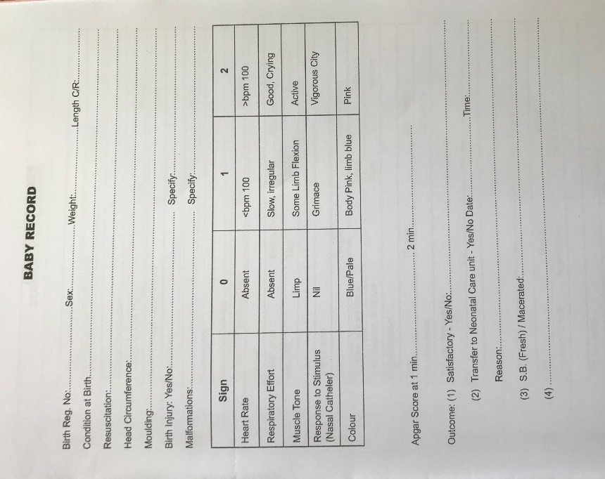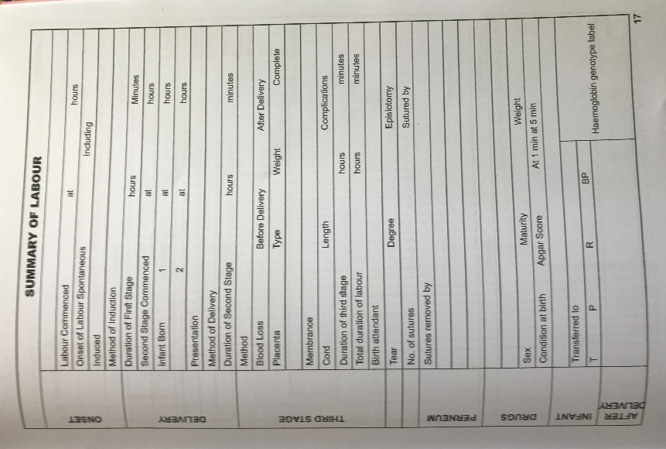

Figure 1. Baby Record and Summary of Labor (Photo by Sangki Oak)

Figure 2. SCBU referral template (Photo by Sangki Oak)

Operating Theatre
Three cases delivered by caesarian section were observed in the operating theatre during the week. While the anesthesiologist is ultimately responsible for neonatal resuscitation, a labor ward nurse or midwife initiates any necessary resuscitation during the surgery. The anesthesiologist will only intervene if resuscitation efforts are being performed poorly or is failing. Before the beginning of the caesarian section, a labor ward nurse or midwife will bring a hospital bassinet with towels, suction, and BVM. There is no neonatal resuscitation equipment stored in the operating theatre. For the cases observed, all necessary equipment was brought in before the case.
One observed case had positive cry and breath and did not need resuscitation. Another case was delivered with a weak cry and low muscle tone. The APGAR score was calculated at 5/10 and resuscitation was initiated. Proper suction was performed, and ventilation was provided by BVM. The newborn infant improved to 8/10 and then 10/10. The final case was delivered with no cry and no breath and was limp and cyanotic. The labor ward staff spent a prolonged time providing suctioning (1 to 2 minutes) and had poor BVM technique with poor rise of the chest on ventilation. The anesthesiologist intervened after a couple minutes and ventilation improved with good result.

Conversations

PHUs and Private Hospitals
Conversations regarding neonatal resuscitation were conducted with nurses, midwives, and community health workers at two private hospitals, one community health center, and two community health posts. Overall, at the PHUs (community health center and community health posts), a total of 7 out of 15 healthcare workers (47%) were trained in neonatal resuscitation through the Helping Babies Breathe program. Individual proportion of trained workers at PHUs ranged from 20% to 71%. At all PHUs, however, training had been provided over a year ago. The healthcare workers emphasized the importance of the training and requested training for their untrained staff and refresher training. One CHP noted that they had one to two apneic newborns a month. For the PHUs, documentation of resuscitation was noted in an HBB receipt booklet (Figure 3).

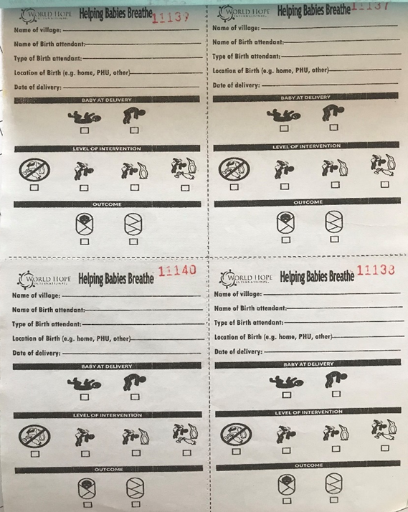

Figure 3. Helping babies breath receipt booklet (Photo by Sangki Oak)

At the private hospitals, conversations revealed that 7 out of 16 delivery attendants (44%) were trained in neonatal resuscitation. At one hospital, all those trained had been trained outside of the hospital at a previous healthcare facility. Workers at both hospitals stated that it had been over one year since they had received training. One nurse complained that there was no HBB training in the private hospital, as the PHUs were preferred sites for HBB training, and requested training at their hospital. Neither hospitals have dedicated space in their documentation for resuscitation efforts, and the only space to record this information is in the comments section of nursing notes.

MRH Labor Ward
In order to better understand resuscitation efforts in the labor ward at Makeni Regional Hospital, discussions with several labor ward nurses, an international midwife, and an international physician were conducted regarding neonatal resuscitation. One nurse stated that she last had neonatal resuscitation training six months ago with one of the doctors. She couldn’t attend the neonatal resuscitation session of a recent ETAT+ training because she was called into the labor ward that day. Other nurses had been able to attend the ETAT+ training. Largely, the nurses expressed confidence in their skill at neonatal resuscitation. Their primary concern was the availability of resuscitation equipment. They stated that they needed additional oxygen generators and complained of a lack of suction bulbs and functional BVMs.
In contrast, the observation of one of the international midwives provided a different perspective regarding the competency of the nurses and midwives in neonatal resuscitation. The midwife felt that the birthing attendants know the theory regarding neonatal resuscitation but are weak on their practical skills. There is often a delay in recognizing the need for resuscitation after delivery. When it is identified, usually the delivery attendant does not call out for help. Therefore, there is frequently only one rescuer providing resuscitation to the neonate. There is also sometimes too much focus on finding oxygen for administration rather than providing ventilation. Therefore, staff waste time searching for an oxygen generator rather than beginning ventilations with a BVM. Since there are no clocks or watches readily available, delivery attendants resuscitating a neonate do not emphasize the golden minute and so delay ventilations for too long and instead spend too much time with stimulation and suctioning. If attendants need to perform compression on a neonate, they often have poor compression techniques. The midwife attributed this to the difference between performing compressions on the training doll and on real patients. Regarding equipment, rescuers often use a BVM mask that is too large and does not provide a good seal. Appropriately sized masks are available, but they do not make the effort to obtain the proper size ones. Equipment is often not prepared and ready beforehand. Masks will sometimes still be sitting in sanitizing solution when resuscitation is needed. Delivery attendants also do not seem to know how to operate the pop-off valve on the infant BVM and risk overinflating the newborn’s lungs. Finally, they do not appear to know how to continue resuscitation efforts for a prolonged period of time. Despite the neonate not yet recovering, they will stop resuscitation too early. They resort to returning to stimulation of the infant rather than continuing ventilation. The midwife emphasized a need for these attendants to continue resuscitation efforts. Regarding the ETAT+ neonatal resuscitation training, they felt that there has been at least one improvement in a recent training they had observed. While practical skills were still limited with each participant only practicing twice (once as a rescuer and once as an assistant), the trainers had begun teaching the assistants to count “breath-2-3” to help the rescuer achieve a proper breathing rate for ventilation. Regarding solutions for improving neonatal resuscitation, the midwife stated that there is a need for more experienced people on the ward to be able to provide hands-on training and mentoring to the delivery attendants on the labor ward. They also stated that equipment should always be prepared and ready to be used before a delivery.
Regarding the challenges to neonatal resuscitation in the labor ward, the international physician shared some of the same concerns. The physician echoed the problem of nurses and midwives not being prepared for resuscitation. In some of the caesarian sections the physician observed, resuscitation equipment had not been brought to the operating theatre by the labor ward staff. Appropriately sized BVM masks were also observed to not be used. Another issue is a lack of emergency drugs for resuscitation in the labor ward. The physician also complained about the doctors not being notified in the event of an emergency. There were also several additional concerns that the doctor shared regarding resuscitation efforts. One problem, in their opinion, is the use of volunteers in the hospital. While volunteers also receive resuscitation training with the staff, they do not necessarily demonstrate proficiency. The doctor also had concerns that the volunteers do not have the same concern for patients as the staff, as the volunteers are only “volunteering” for money (“volunteer” has a different connotation in Sierra Leone and they receive some fees from the patients). They stated that while midwives and nurses are in the labor ward between 8 am and 9 pm, only volunteers are working in the ward between 9 pm and 6 am, as well as weekends, and the doctor claimed an increase in the rate of fresh stillbirths during these periods. The doctor also felt that, overall, the delivery attendants have an attitude that accepts death too readily which affects their motivation for resuscitation. They feel that the attendants think that the mother can simply become pregnant again so that they are not required to make the efforts to resuscitate a potential stillbirth. Regarding solutions to the problems in neonatal resuscitation, the physician also echoed the need for mentoring in the ward to provide guided training during real resuscitation efforts. They felt, though, that there are not currently enough mentors to provide this mentorship on the wards.

MRH Operating Theatre
Conversations with the anesthesiologists in the operating theatre of MRH were also conducted regarding neonatal resuscitation, and they had similar concerns regarding the lack of proficiency of midwives in neonatal resuscitation. The anesthesiologists felt that the midwives do not adequately assess the newborns, do not suction, and spend too much time drying and stimulating apneic neonates rather than providing ventilation. They felt that more proper training is needed.
The anesthesiologists also provided some insight about the protocols used for initiating neonatal resuscitation and in documentation of resuscitation efforts in the operating theatre. When a baby is delivered by caesarian section in the operating theatre, the anesthesiologist looks at the fetal cord for pulsations to indicate a heartbeat. They will also consider fetal heart rates obtained by doppler or ultrasound before delivery. If there was no fetal heart rate prior or there is no pulsation of the cord at delivery, they declare the neonate dead and a stillbirth. No resuscitation is conducted. If there is at least pulsation of the cord, then an APGAR score of 1/10 or greater is given and resuscitation is initiated if needed. It should be noted that both the ETAT+ neonatal resuscitation protocol and the HBB protocol do not advocate pulse checks until at least one minute after ventilation has been initiated and recommend discontinuing resuscitation efforts only after 10 minutes without a pulse.
For documentation, the anesthesiologist is responsible for recording the condition of the newborn in the anesthesia record (Figure 4) under Anaesthesia Technique. This is indicated through the one, five, and ten-minute APGAR scores. They assume that resuscitation efforts are to be interpreted based on the trend of the APGAR scores. If a low APGAR score is recorded, then it is assumed that resuscitation had been initiated. An improved APGAR score indicates that resuscitation was successful. As noted earlier, there is no dedicated space for resuscitation efforts in the anesthesia record, though one anesthesiologist said that they would document resuscitation effort if it was indicated in the record.

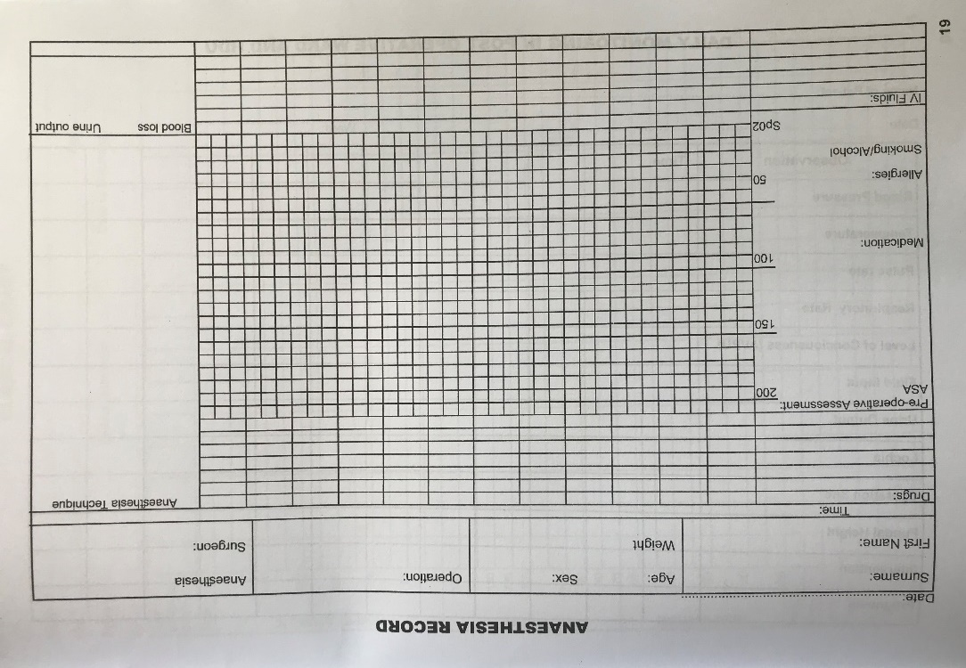

Figure 4. Anaesthesia record in maternal patient record (Photo by Sangki Oak)

Discussion
Though it is difficult to determine causal effects of neonatal resuscitation on stillbirths in the Bombali Shebora chiefdom due to the lack of current data regarding resuscitation efforts for all apneic neonates during delivery, the CHAMPS data, combined with observations and conversations with health workers, is able to at least provide a picture regarding neonatal resuscitation as it relates to stillbirths. From the documented resuscitation efforts, we can see that only 14% of all stillbirths received resuscitation while 25% fresh stillbirths received resuscitation (Table 1). The majority of the stillbirths are being confirmed by physical exam at the time of delivery (Tables 5 and 6). Since almost half of stillbirths are classified as fresh, it is unclear why resuscitation efforts were not initiated for more of these cases. Based on both the observations and the conversations, one possible cause is failure to recognize and initiate the need for resuscitation of the neonate. Breath checks were rarely, if at all performed, and ventilation was often delayed. We can also see that the majority of stillbirths occurred in the hospital setting, which makes sense due to the larger volume of deliveries at these locations. However, the rate of resuscitation at hospitals was 3.7%, which is 11 to 12 times lower than at the PHUs. From the conversations with the anesthesiologists, we observe that the operating theatre follows a protocol for neonatal resuscitation that is different than that advocated by ETAT+ and HBB. While neonatal resuscitation protocols recommend initiating resuscitation regardless of fetal pulse, the operating theatre does not provide neonatal resuscitation if a cord pulse is not detected.
One central issue in analyzing the CHAMPS data regarding resuscitation efforts in relation to stillbirths is the insufficient documentation of resuscitation. Only 42.3% of stillbirths had documentation whether resuscitation was attempted or not (Table 1). The community health centers had the highest rates of documentation at 66.7% (Table 2) which could be attributed to the simple documentation format of the HBB booklet. But the community health posts also use the HBB booklets and still have lower documentation rates, similar to the hospitals. The deficiency in documentation at the hospital can be attributed at least in part to a combination of a lack of documentation in the patient records in general and few dedicated areas in the patient records to note resuscitation efforts, in particular for neonates that are delivered in the operating theatre and those that are referred to the SCBU. Since neonatal resuscitation training doesn’t mention the need for documentation of resuscitation efforts, delivery attendants may also not be aware of the importance of proper documentation.

Areas for Improvement
While we are unable to draw definitive conclusions regarding neonatal resuscitation in Sierra Leone, the results of this study suggest two areas of improvement that could help mitigate neonatal deaths: documentation and training. The first is in regard to proper documentation of resuscitation efforts within patient records. While this study provides an initial analysis of neonatal resuscitation efforts during delivery, there is still much research that needs to be done. In order to accomplish this, CHAMPS will need improvements in the collection of data in these efforts. One issue is the lack of dedicated space within the patient records for delivery attendants to easily record resuscitation attempts. Since it would be difficult and costly to reprint hospital records for each of the facilities, we would recommend that small stickers be created with similar pictograph and check boxes as the HBB receipts (Figure 3) and distributed to the hospitals. These stickers would then be ideally placed in the maternal records, SCBU referrals, and anesthesia notes by the hospital administration or, less preferably, by the staff in wards during or after resuscitation. This would provide a reminder for documentation with a quick and easy way of recording efforts. In addition, training should be provided to highlight the importance of documentation and the methods to do so. This can be done in conjunction with neonatal resuscitation training or separately.
The other area for improvement is that of neonatal resuscitation training. For the PHUs and private hospitals, more training is needed to educate new students in neonatal resuscitation, as well as to provide refresher training to those that have previously received it. Most of the staff for many of the PHU’s and private hospitals do not have training in neonatal resuscitation, and those that do have not received refresher training in over a year. These are necessary and perishable skills that require periodic training to retain proficiency. The HBB program should be expanded to provide training to all the PHUs in the area and at intervals of at least once a year. In addition, either HBB or other structured neonatal resuscitation training should be expanded to the private hospitals to ensure the delivery attendants there are proficient in resuscitation as well. For the government hospitals, in particular Makeni Regional Hospital, we recommend improvements in their current resuscitation training. Practical skills training should be modified to have smaller groups with more rounds of practice. In addition, while it is admirable to emphasize local trainers to promote sustainability in the training, given the current quality of proficiency in resuscitation more oversight may be needed to ensure proper emphasis on technique is provided. Additional training may be necessary for the anesthesiologists to advocate initiating resuscitation efforts despite no fetal cord pulse.
Ultimately, as highlighted by observation and discussions, what will be most important to ensure quality neonatal resuscitation is being performed is mentorship on the various wards. This area of improvement will be slow to implement, though, as there are insufficient adequately trained mentors to provide this oversight and it will take time to develop new ones. One suggestion would be to develop a program to encourage, and possibly reward, those that demonstrate excellent proficiency in resuscitation and the desire to mentor others in these skills. Hopefully, the desire this can help foster a culture of excellence and mentorship within the hospital.

Public Health Relevance
The purpose of this essay is to describe the work by the CHAMPS program to combat newborn and childhood mortality in Sierra Leone and examine newborn resuscitation efforts using the data collected by the program. In resource limited countries such as Sierra Leone, most of the healthcare efforts are focused on addressing the immediate health needs of the people such as combating active infections or providing surgical care for trauma. Unfortunately, this means that insufficient data is collected regarding the causes of death in the population and few resources are allocated for prevention. Therefore, when a child or newborn dies in Sierra Leone very often there is no autopsy or other post-mortem investigation and the cause of their death is unknown. Without data to inform decisions there can be no evidence-based interventions to prevent illness and injury in children. The CHAMPS network in Sierra Leone is a public health initiative to provide this data on stillbirths and under-5 child mortality. Verbal and social autopsies, along with the MITS sampling, will allow determination of the cause of death for these children and provide guidance to the MoHS to effectively allocate resources to implement public health programs to reduce future child deaths. The newborn resuscitation study from the CHAMPS data looked specifically at stillbirths and the resuscitation efforts in their care. While definitive conclusions are unable to be determined due to insufficient documentation, the study does suggest the need for improving and expanding efforts for newborn resuscitation training. The hope is that these public health efforts can reduce stillbirths in this region of Sierra Leone and beyond.

Limitations
There are several limitations to this study. Due to the lack of current data regarding overall births and resuscitation efforts on apneic newborns that survive, it is difficult to determine any causal relationships using the CHAMPS data. For example, while the hospital resuscitation rates on stillborn are low compared to the PHUs, this could indicate better quality resuscitation at the hospital resulting in greater number of apneic newborns that survive. Though observational information and conversations suggest otherwise, we are unable to make a determination such as this conclusively. There are also limitations in the data due to the lack of documentation regarding resuscitation for the majority of the stillbirth cases. The qualitative picture indicates that resuscitation efforts are being conducted in the operating theatre but are not being adequately recorded for entry into CHAMPS. This data has the potential to change some of the results that have been reached. Finally, due to constraints in time and resources, there were limitations regarding the number of facilities and deliveries observed and number of discussions with personnel regarding resuscitation. The observations and conversations are thus only able to provide some insight into the challenges and needs for neonatal resuscitation and cannot presume to provide a comprehensive picture. While suggestions can be made by this initial analysis, definitive assessments cannot be drawn.

Conclusion
In order to meet the ENAP goal of stillbirth rates, as well as reduce overall neonatal and child mortality in the country, Sierra Leone must continue to make drastic improvements in its health programs and services. The CHAMPS network is uniquely positioned to provide assistance by identifying the causes of death in neonates and children so that resources and efforts can be focused on addressing these sources. This study sought to perform an initial analysis of this data in order to determine if neonatal resuscitation efforts were being made on patients that were classified as stillbirths. The results along with the observations and conversations, while not definitive, suggest that improvements need to be made in neonatal resuscitation training and application in healthcare facilities in the region and that there will be challenges to these changes. We can also see the power and value of CHAMPS in providing data to address questions such as these. Without the CHAMPS database, collecting the information for this study would have been difficult, if not nearly impossible. As the network matures, the potential to answer even more complex and pressing questions regarding child health and mortality will continue to grow. For this to happen though, continuous improvements in the data collection and constant support for the CHAMPS project by the MoHS and other organizations will be necessary to allow it to succeed. This should help to provide a brighter future for the children of this country.

Bibliography
- Africa::Sierra Leone. The World Factbook. Central Intelligence Agency. https://www.cia.gov/library/publications/the-world-factbook/geos/sl.html. Last accessed: February 8, 2020.
- “Enrolled Population Summary”. CHAMPS: Child Health and Mortality Prevention Surveillance. https://champshealth.org/champs-summaries/. Last accessed: March 27, 2020.
- “Every Newborn: An Action Plan to End Preventable Deaths”. World Health Organization. June 2014.
- Lawn JE et al. “Stillbirths: rates, risk factors, and acceleration towards 2030”. Lancet 2016; 387: pp 587-603.
- “Maternal Death Surveillance & Response: Annual Report 2016”. Directorate of Reproductive & Child Health, Ministry of Health & Sanitation. May 2017.
- Berkelhamer SK, Kamath-Rayne BD, and Niermeyer S. “Neonatal Resuscitation in Low-Resource Settings”. Clin Perinatol 43 (2016): pp 573-591.
- Wall SN et al. “Reducing Intrapartum-Related Neonatal Deaths in Low- and Middle-Income Countries—What Works?”. Semin Perinatol 34 (2010): pp 395-407.
- Wall SN, Lee AC, Niermeyer S, et al. “Neonatal resuscitation in low resourcesettings: what, who, and how to overcome challenges to scale up?”. Int J Gynecol Obstet 107 (2009):pp 47-64.
- Msemo G, Massawe A, et al. “Newborn Mortality and Fresh Stillbirth Rates inTanzania After Helping Babies Breathe Training”. Pediatrics 2013; 131:pp 353-360.
- World Health Organization. “Saving lives through streamlined emergency care”. ReliefWeb. December 15, 2017. https://reliefweb.int/report/sierra-leone/saving-lives-through-streamlined-emergency-care. Last accessed: June 11, 2019.
- “Helping Babies Breathe”. Healthy Newborn Network. https://www.healthynewbornnetwork.org/partner/helping-babies-breathe/. Last accessed: June 11, 2019.
- Statistics Sierra Leone. Population and Housing Census 2015. Summary of final results, 2016.
- PA Harris, R Taylor, R Thielke, J Payne, N Gonzalez, JG. Conde “Research electronic data capture (REDCap) – A metadata-driven methodology and workflow process for providing translational research informatics support”. J Biomed Inform. 2009 Apr;42(2):pp 377-81.
- PA Harris, R Taylor, BL Minor, V Elliott, M Fernandez, L O’Neal, L McLeod, G Delacqua, F Delacqua, J Kirby, SN Duda. “REDCap Consortium, The REDCap consortium: Building an international community of software partners”. J Biomed Inform. 2019 May 9 [doi: 10.1016/j.jbi.2019.103208]

